**RDS-Relational Database Service (Windows)**

**LAB:**

Create a database

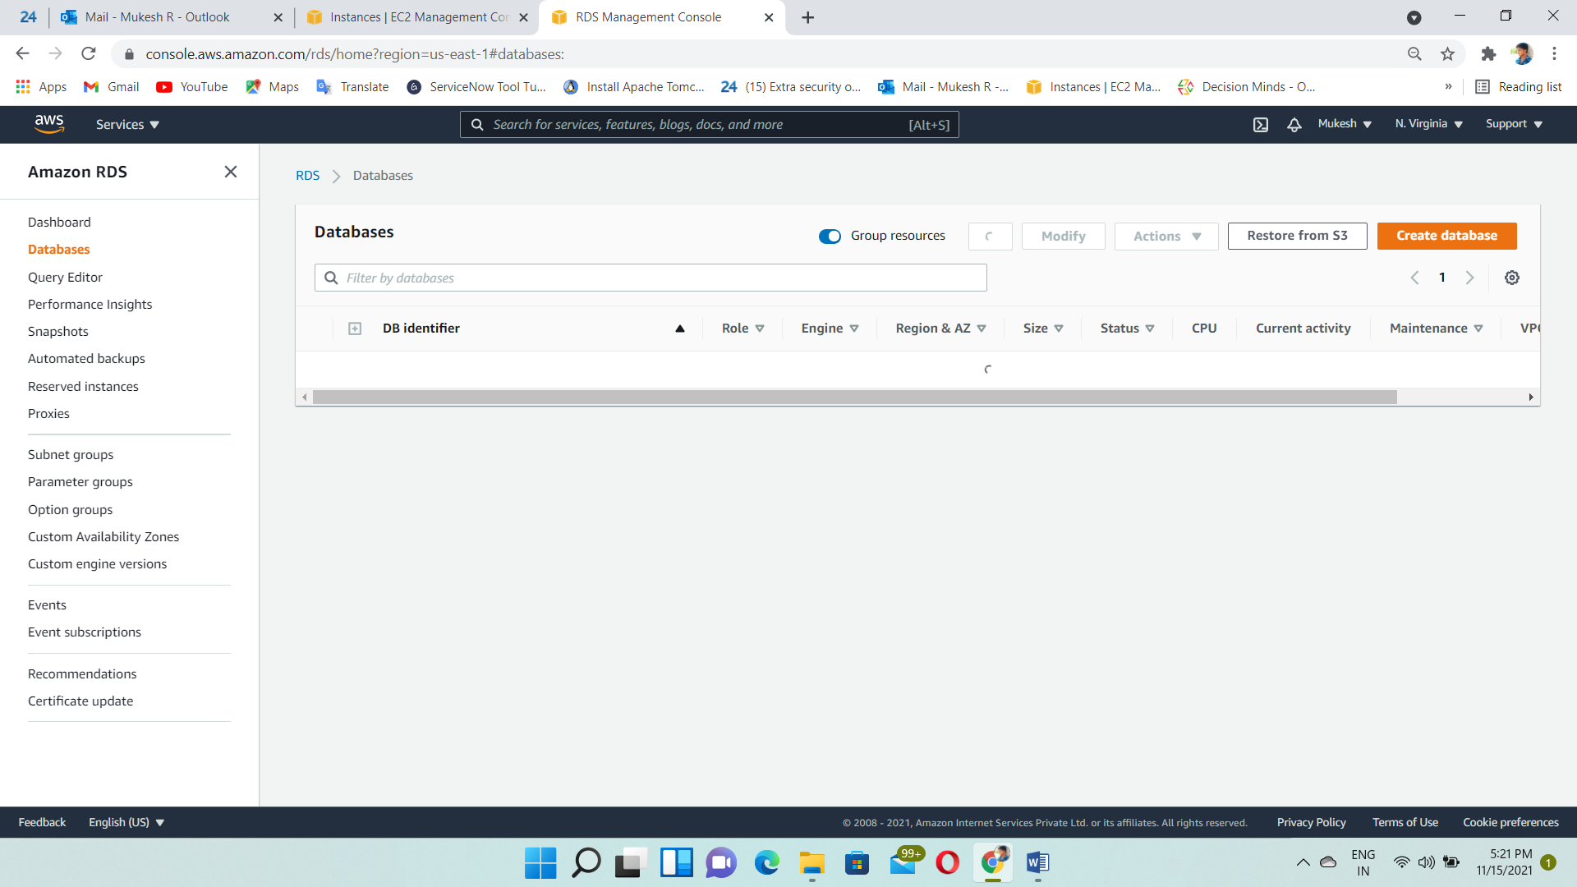

Select MySQL engine type

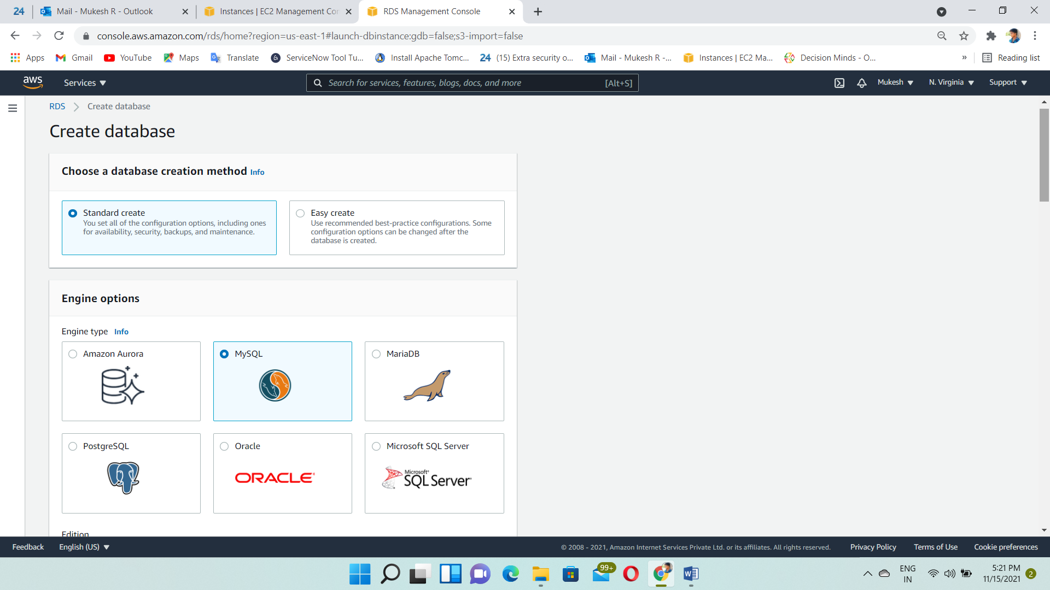

Select the version 5.7.22 and choose free tier

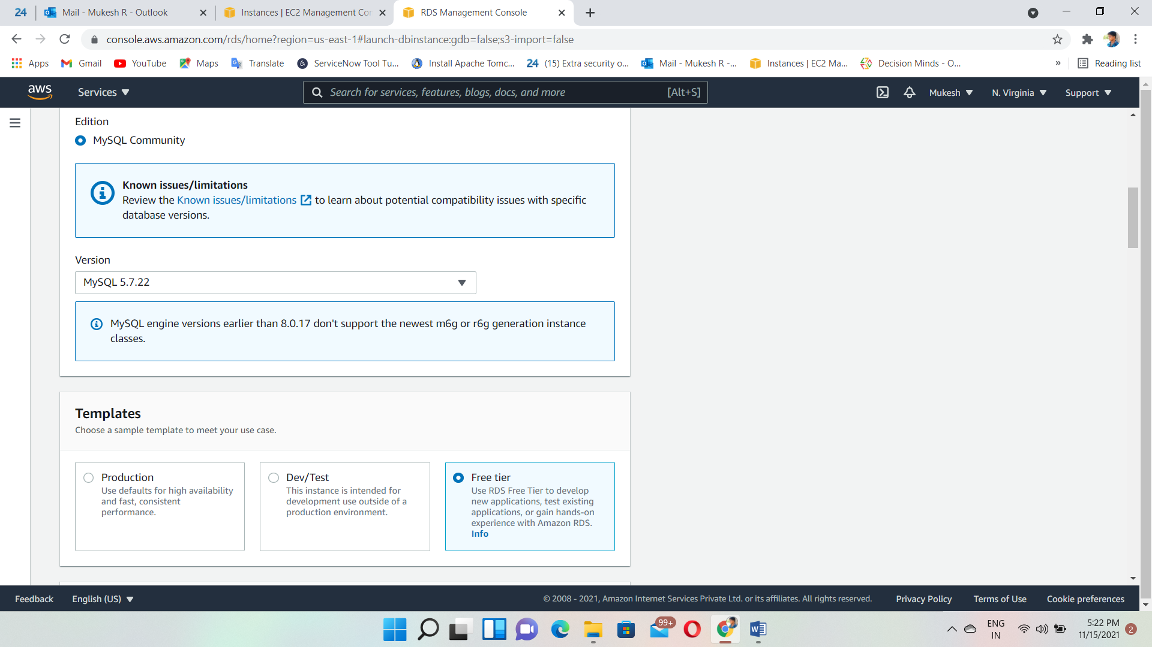

Give the DB instance Name and Username, Password

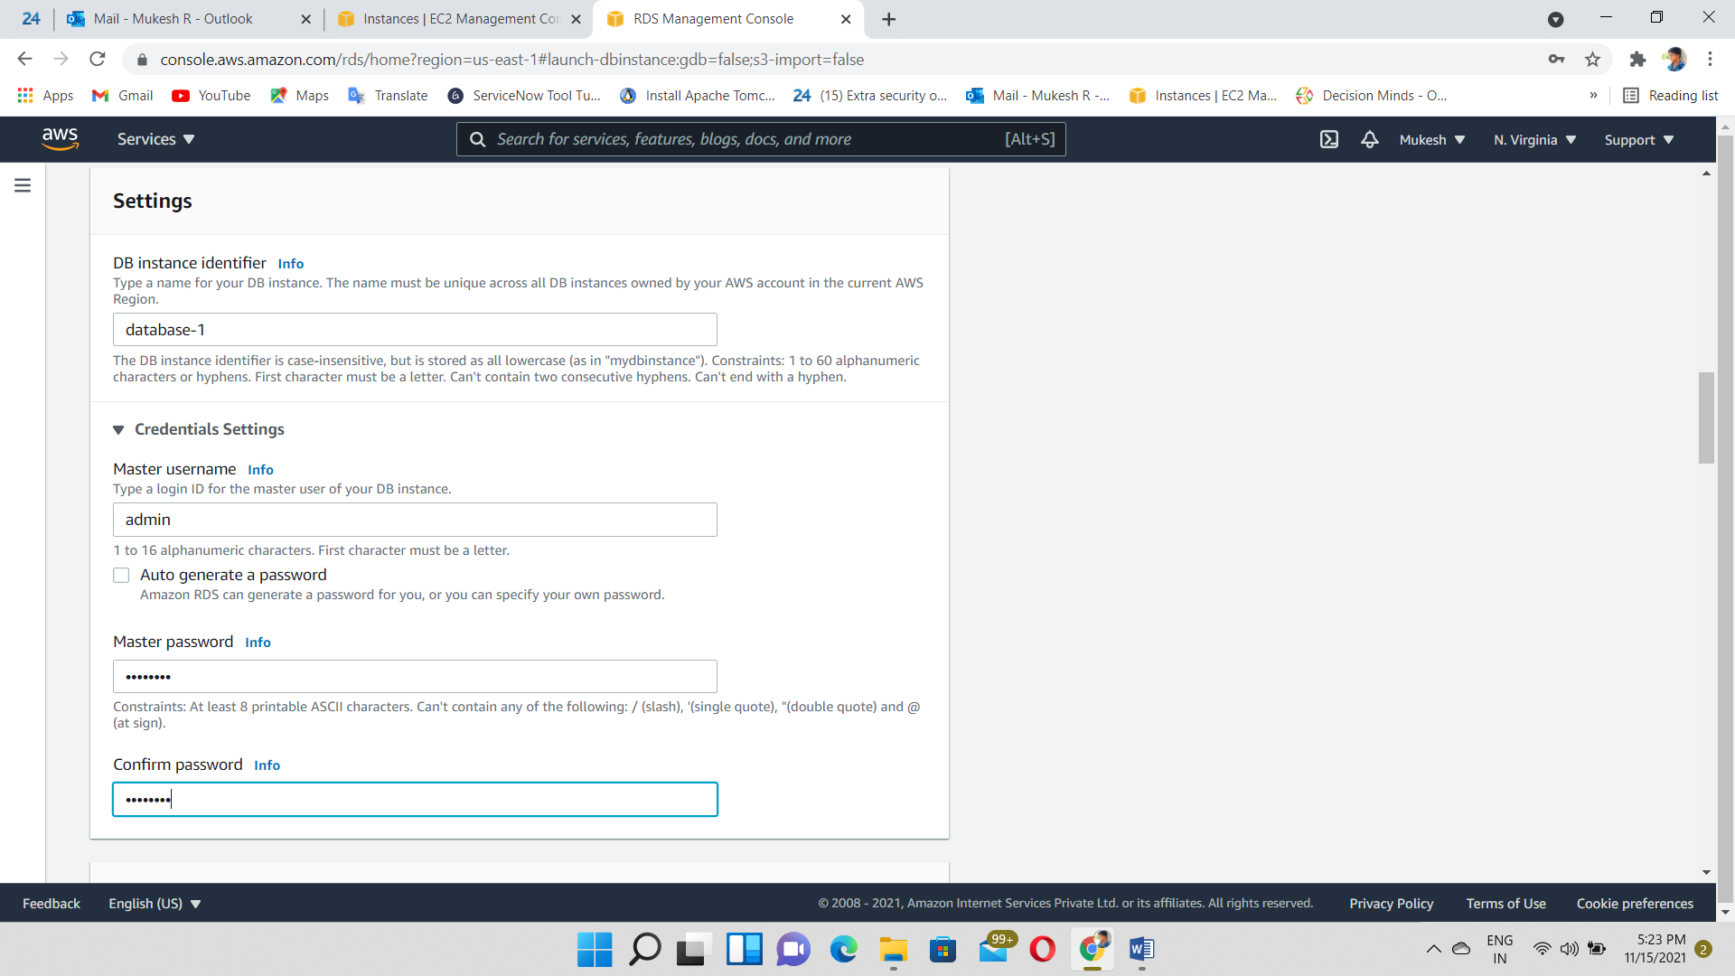

Allocated the storage and disable storage autoscaling

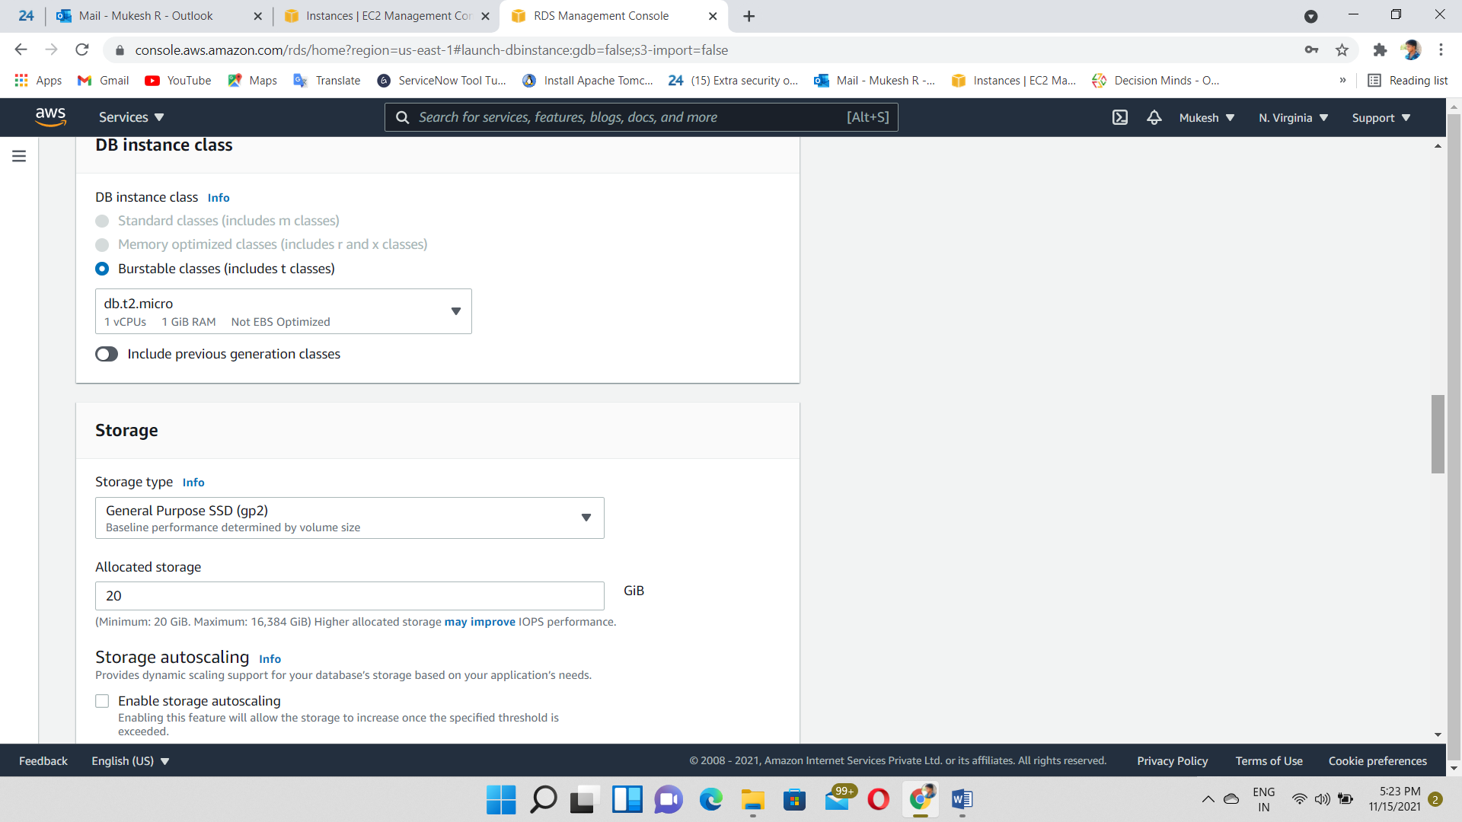

Give to DB instance details🡪VPC, Subnet…

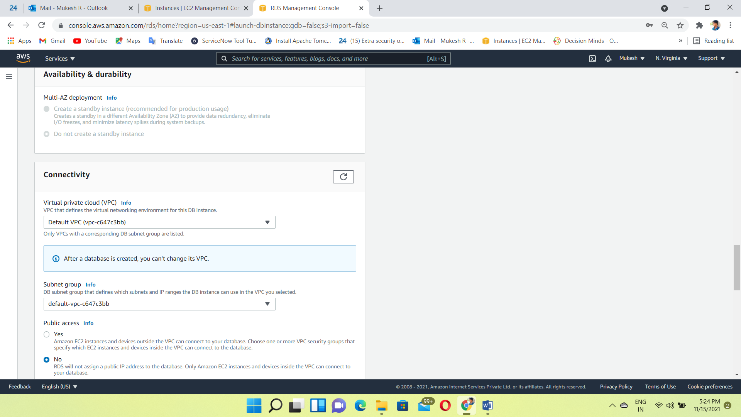

Select All traffic security group

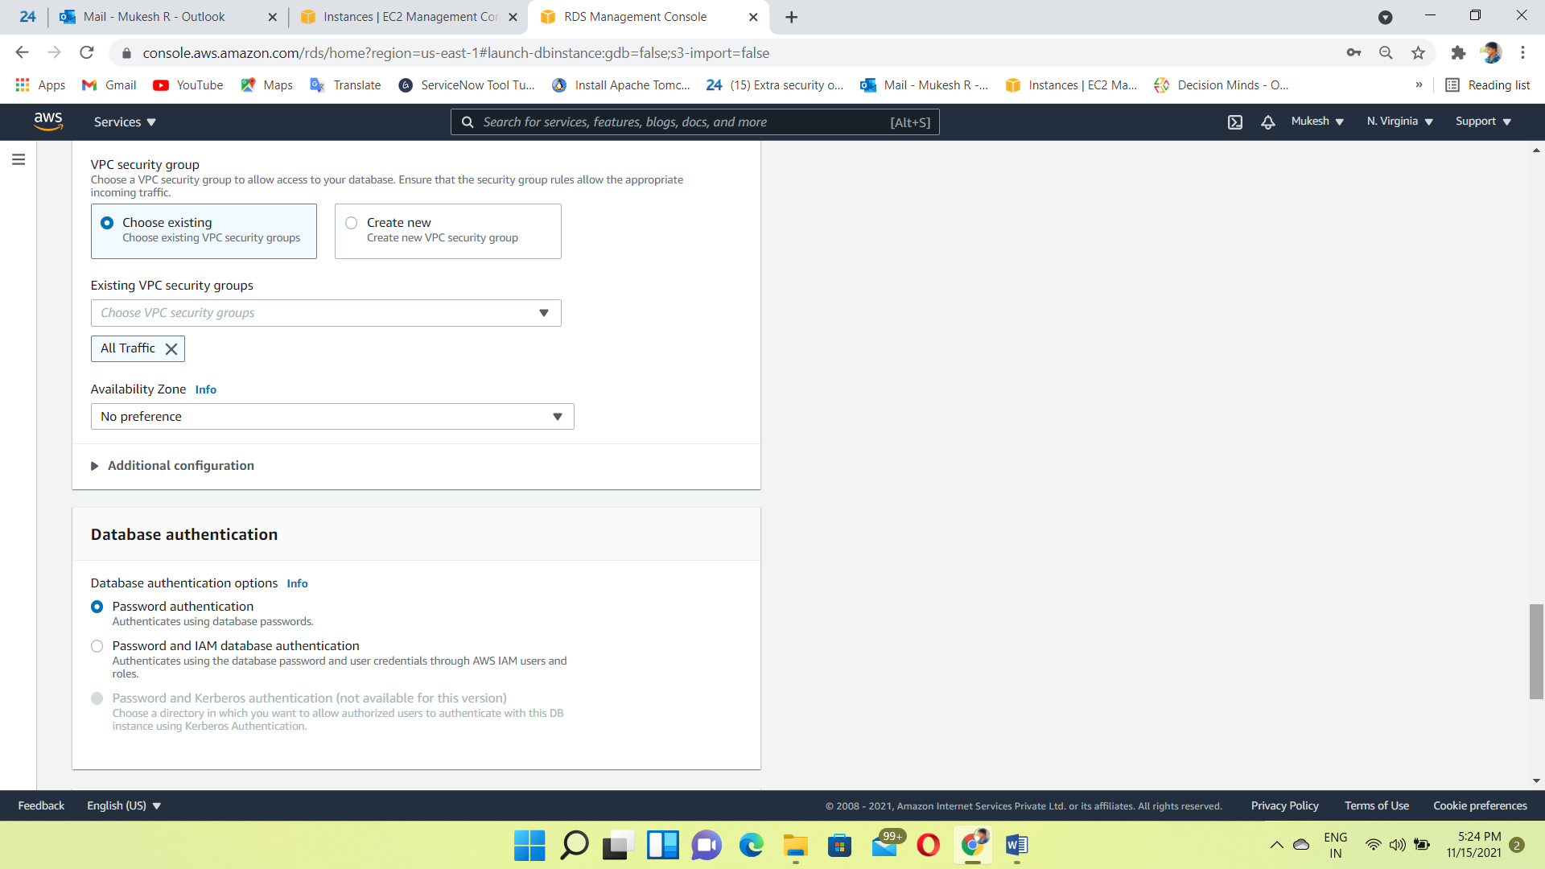

Create a windows instance (Frontend Application)

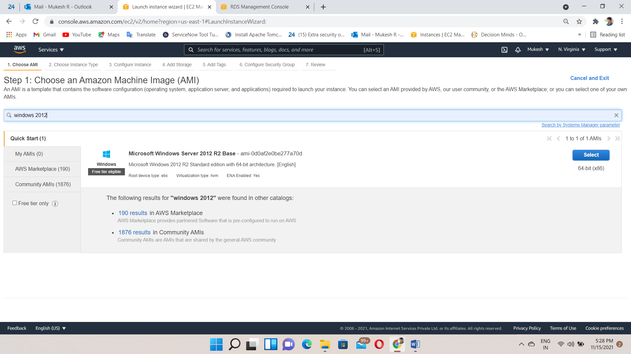

Instance Created

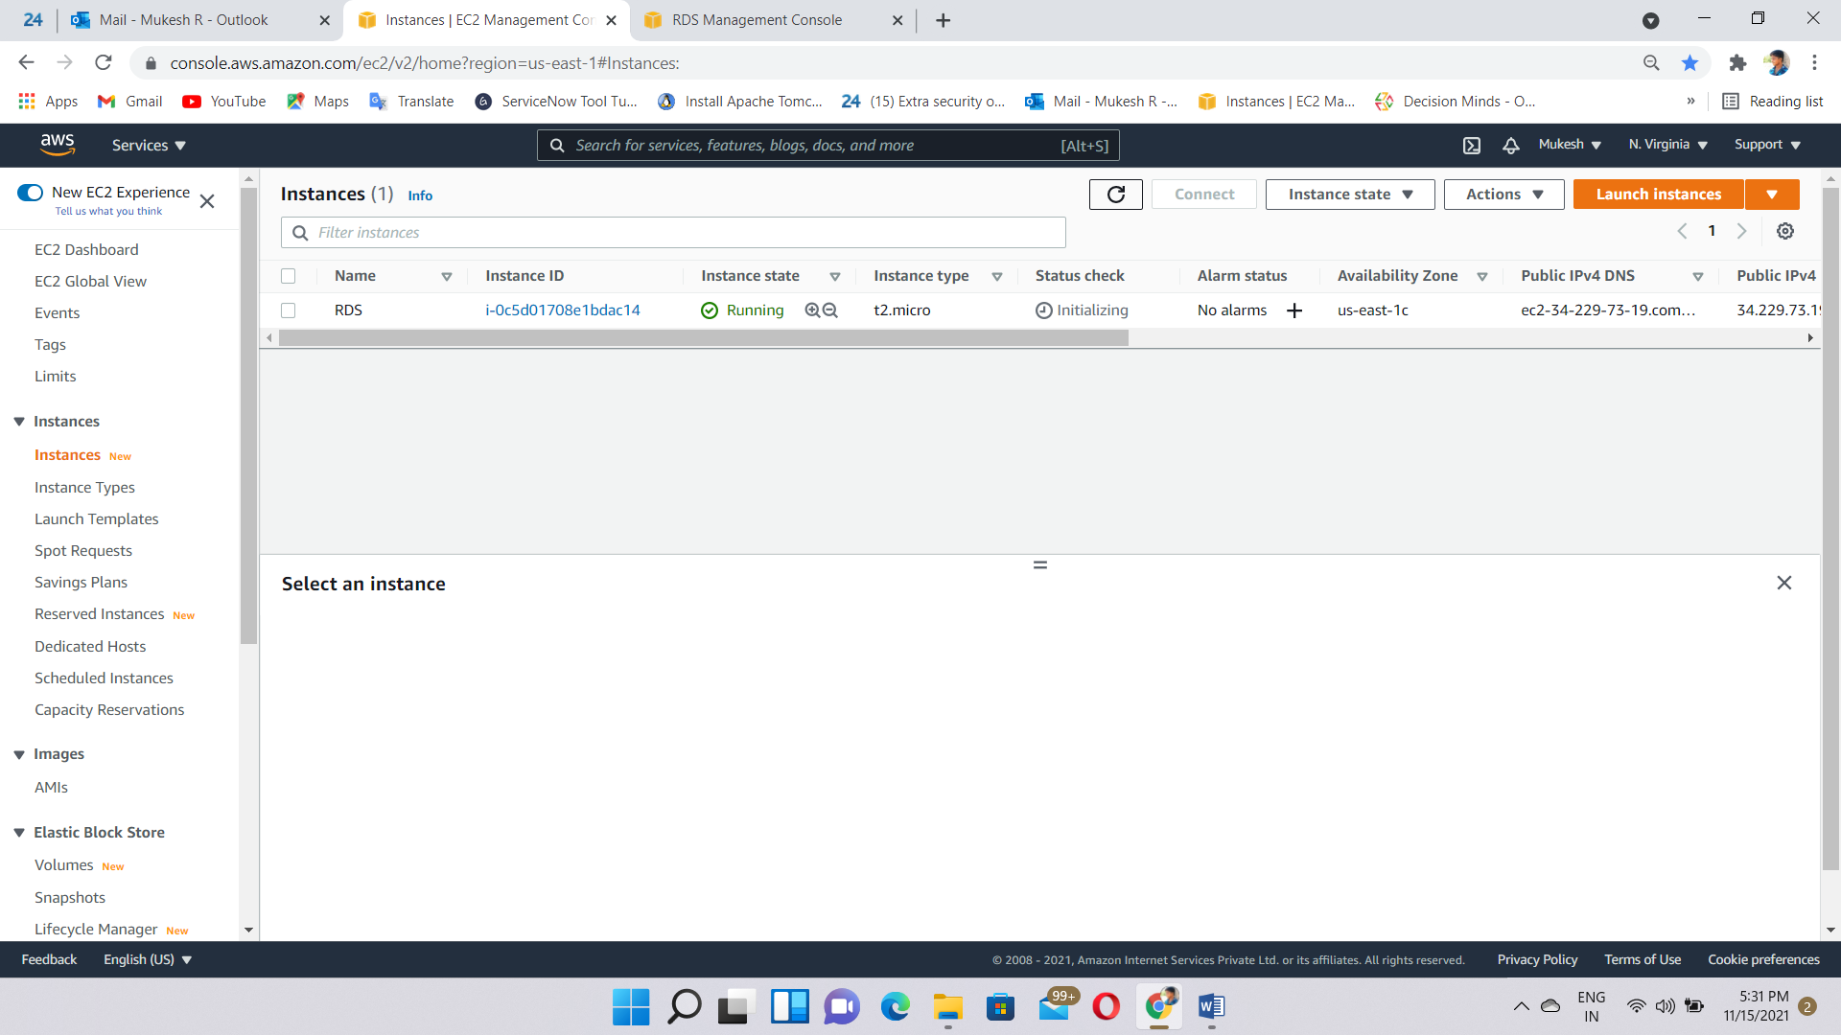

DB instance also created and check the status “available”

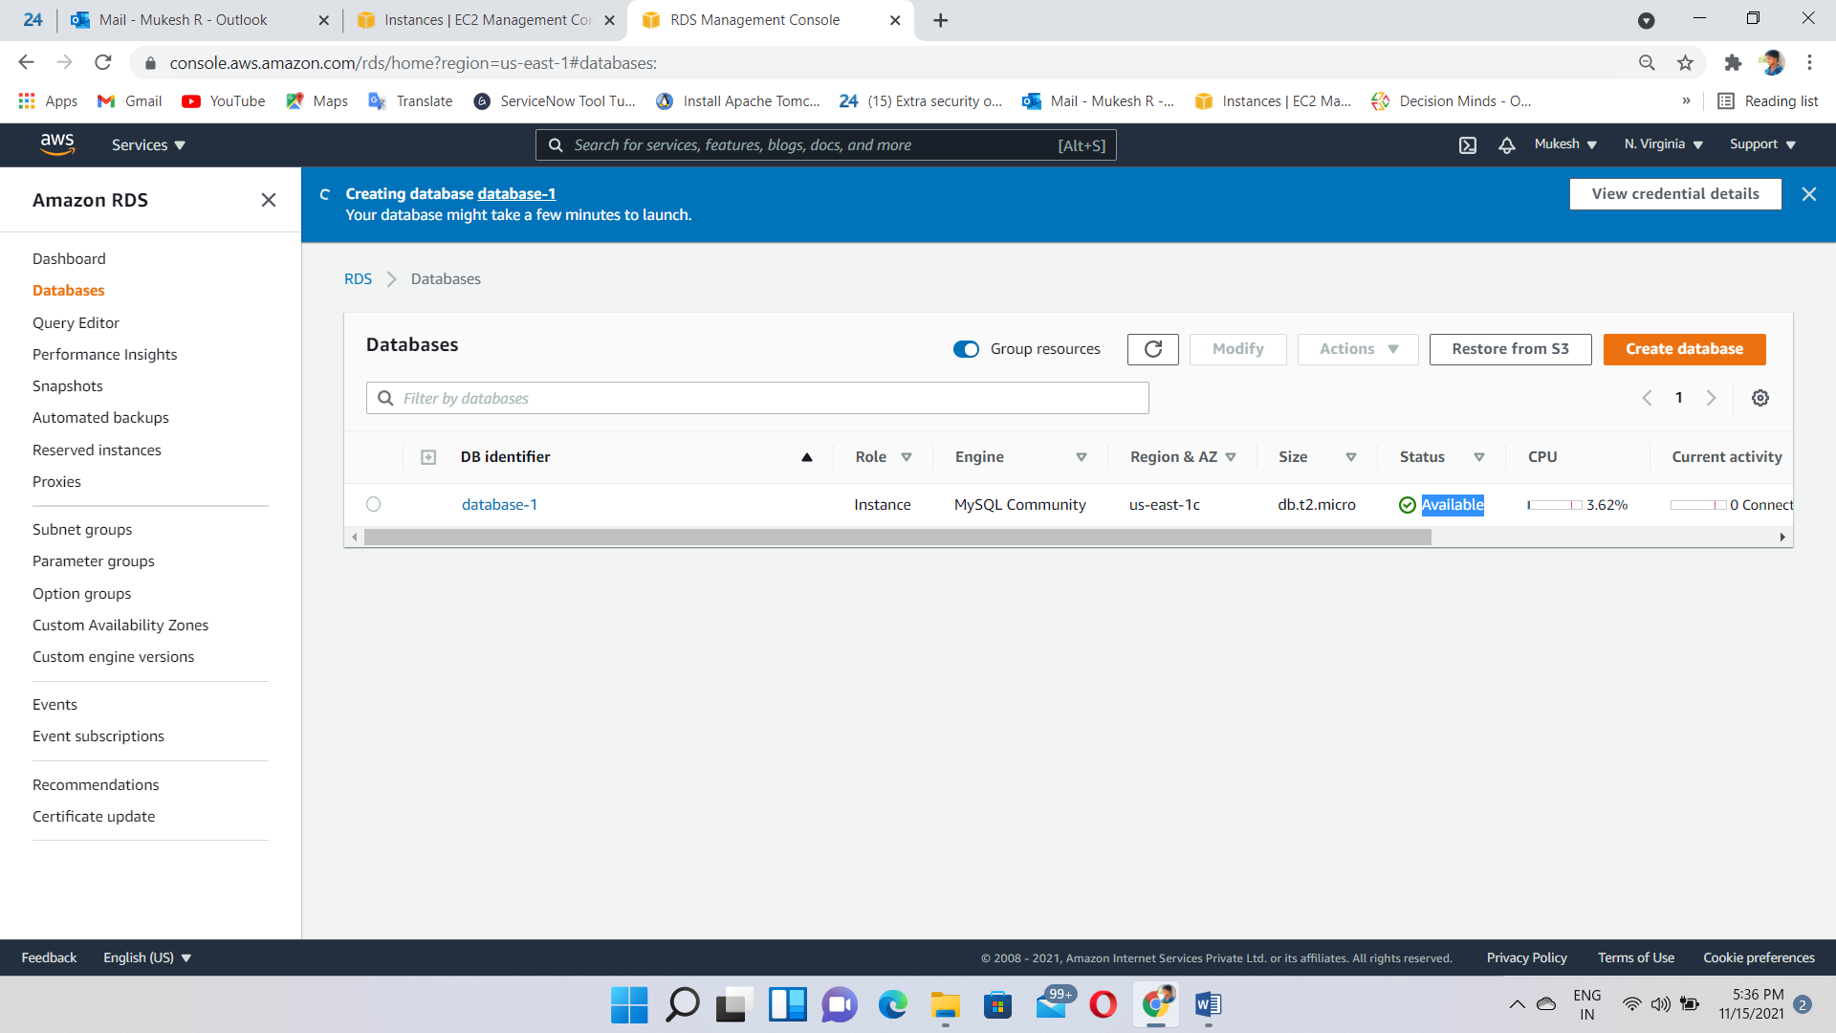

Login to the windows instance using credentials

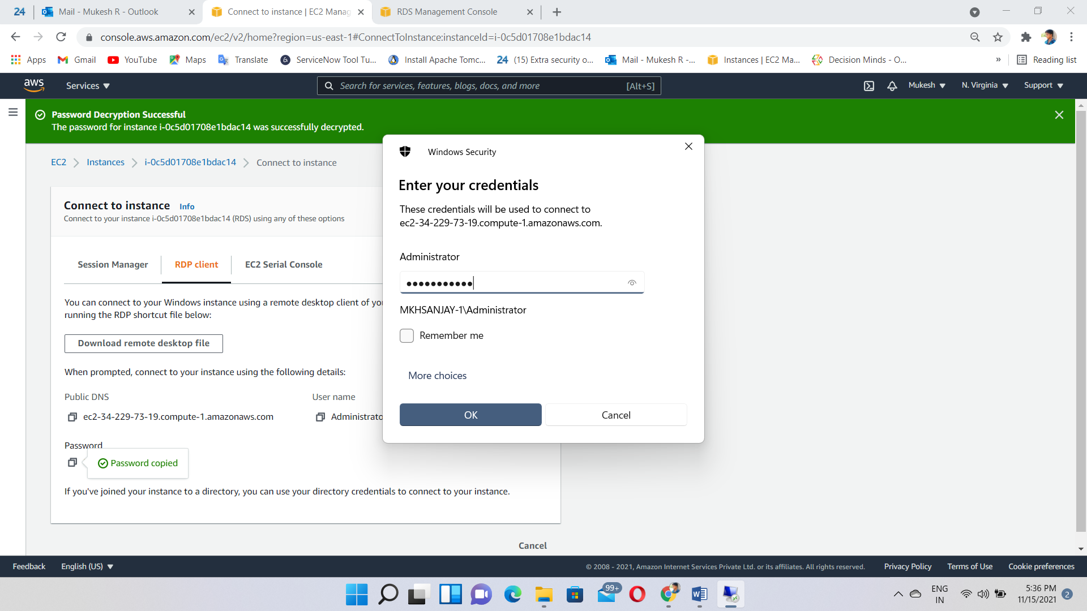

Search “internet Explorer”

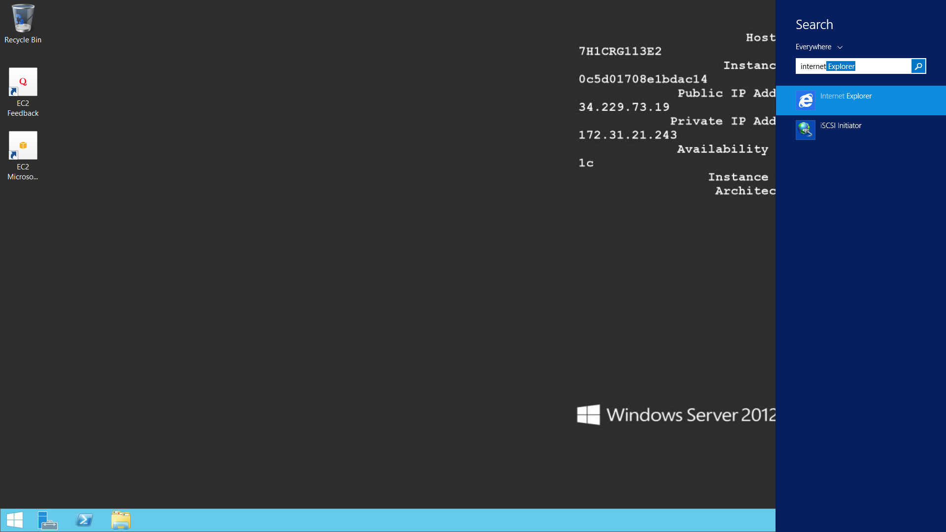

Download MySQL engine🡪<https://dev.mysql.com/downloads/workbench/>

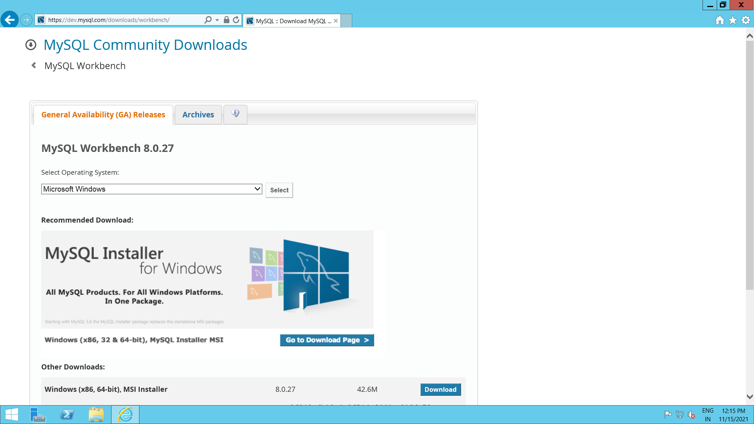

Downloaded

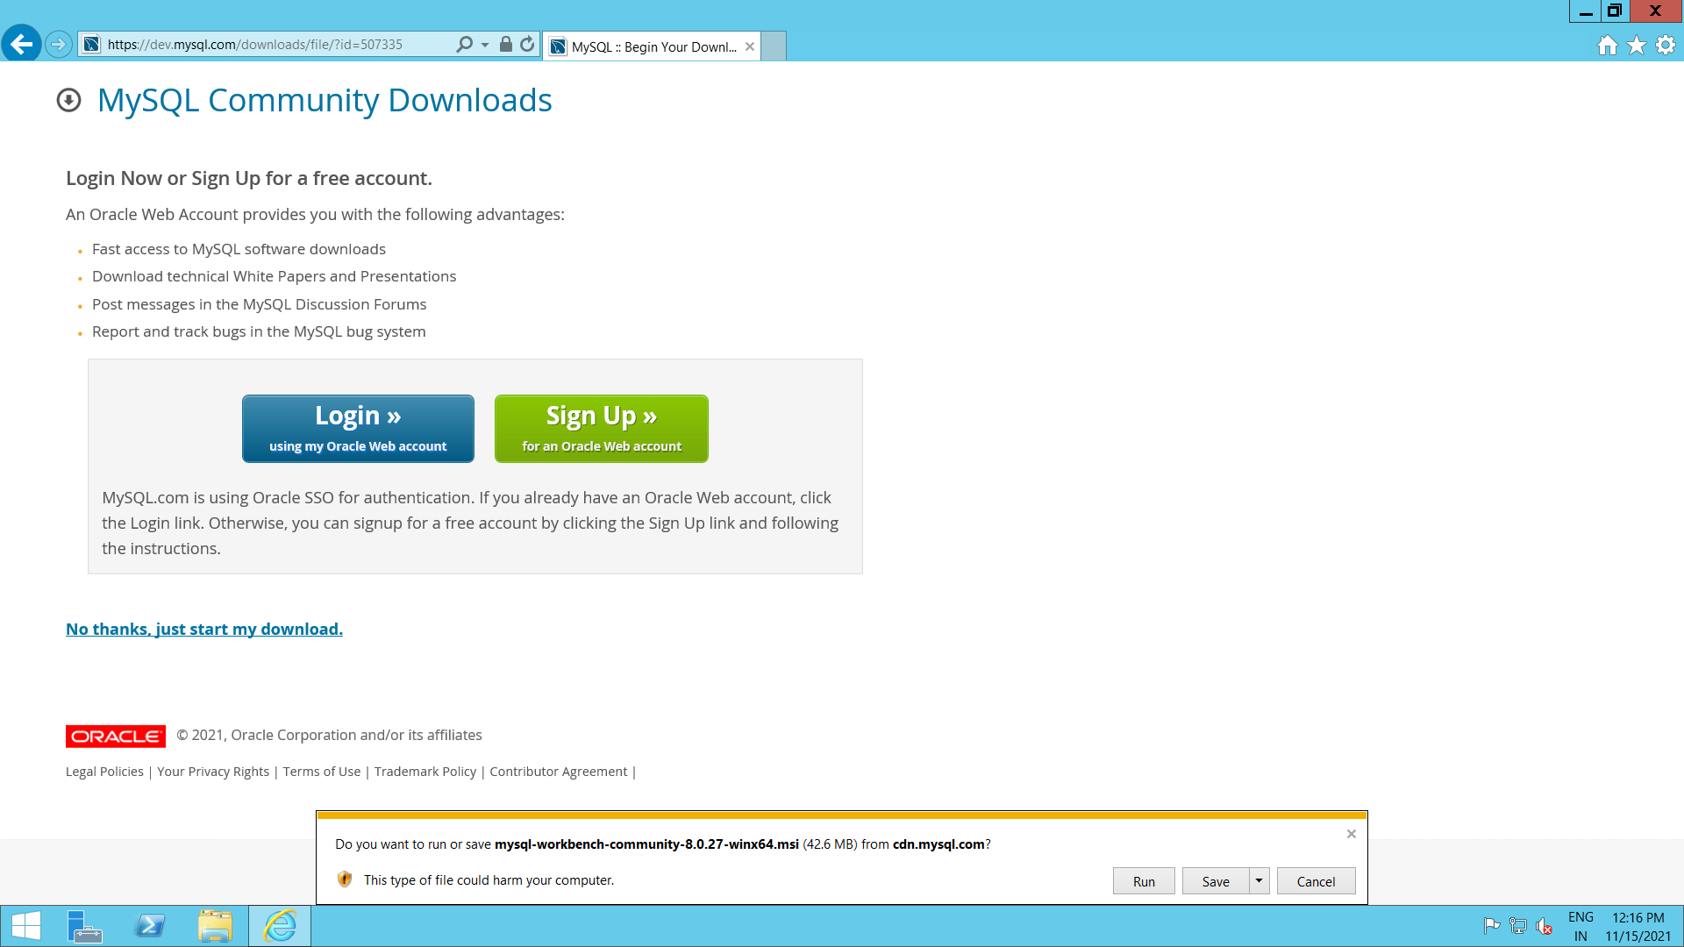

Installing the MySQL engine

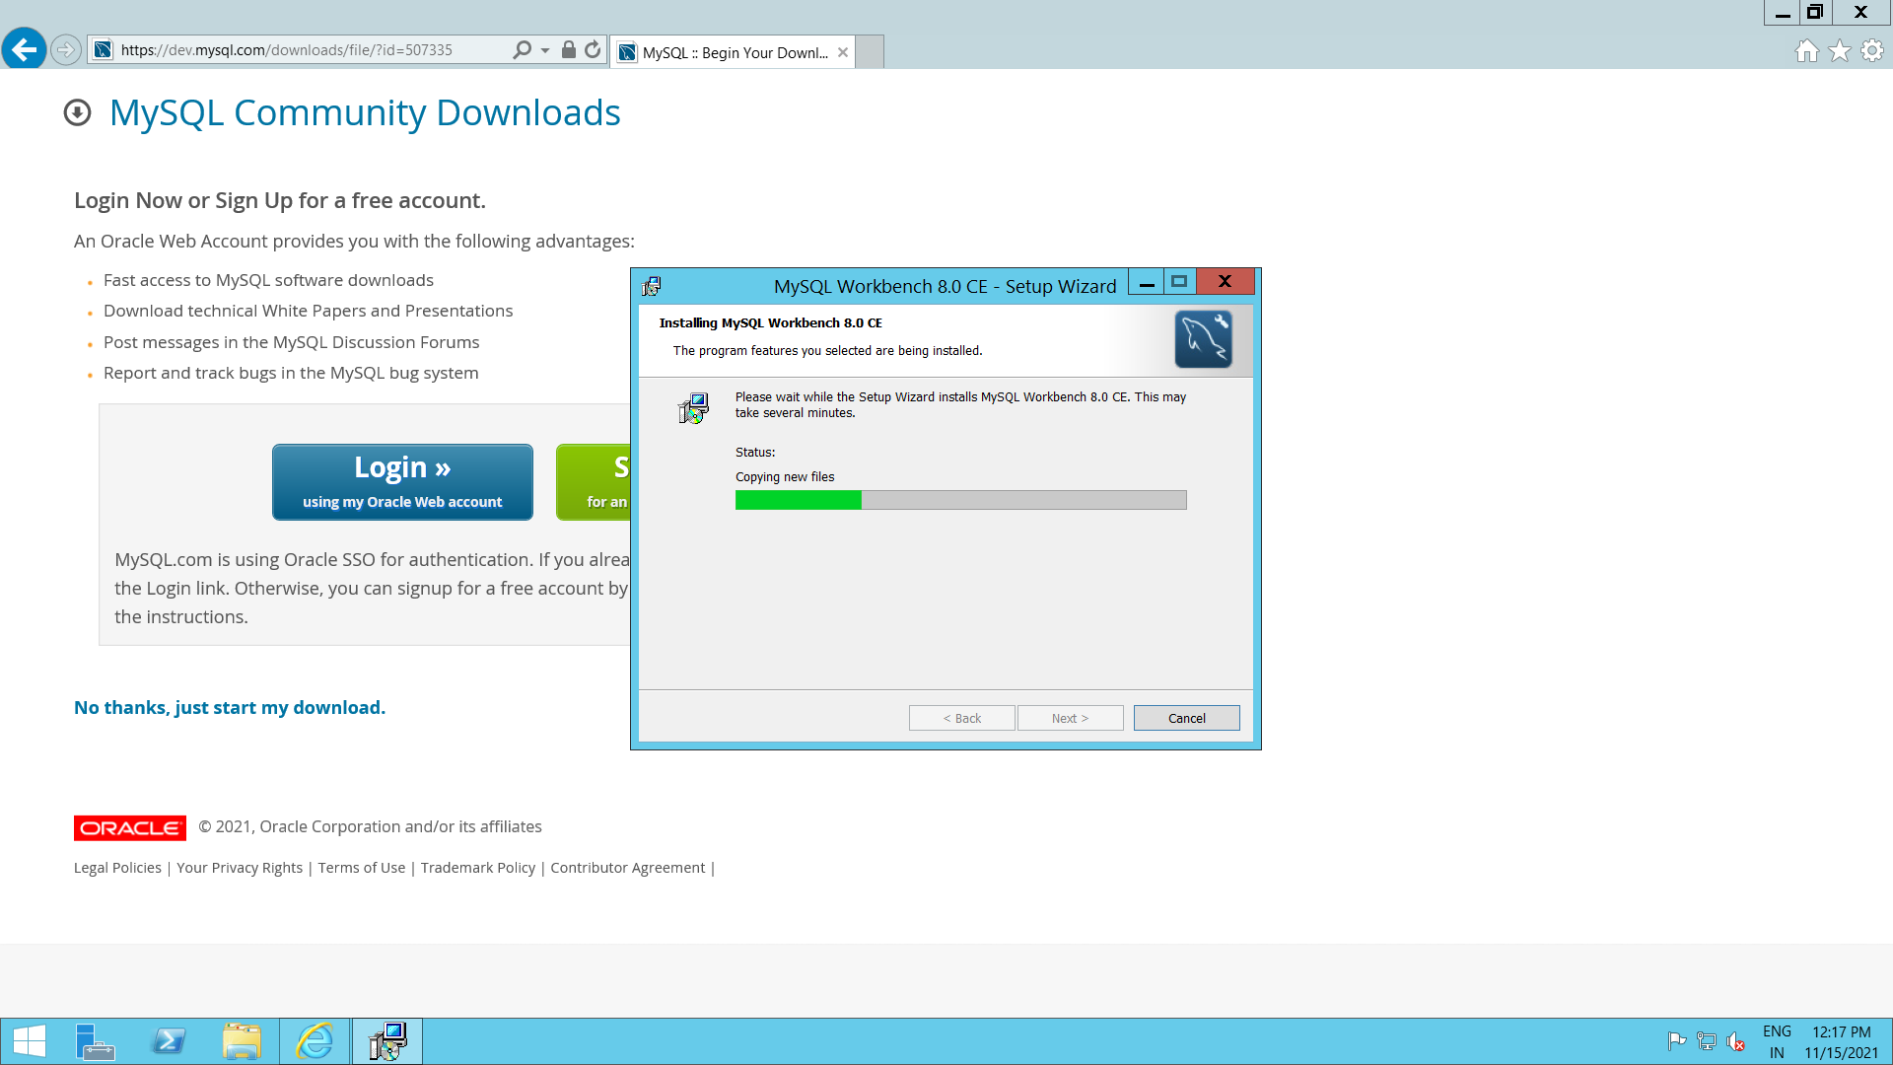

Installation Completed

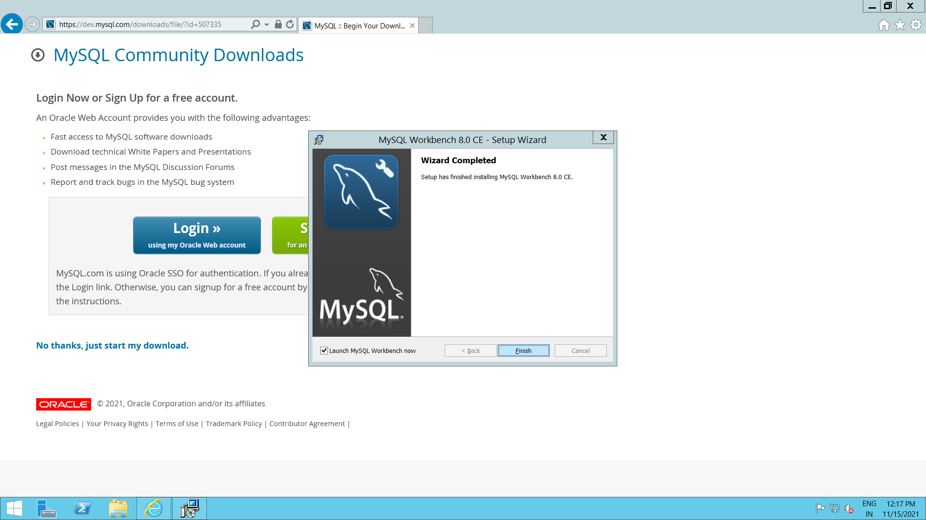

Enter the Hostname(endpoint), port number, username and Password

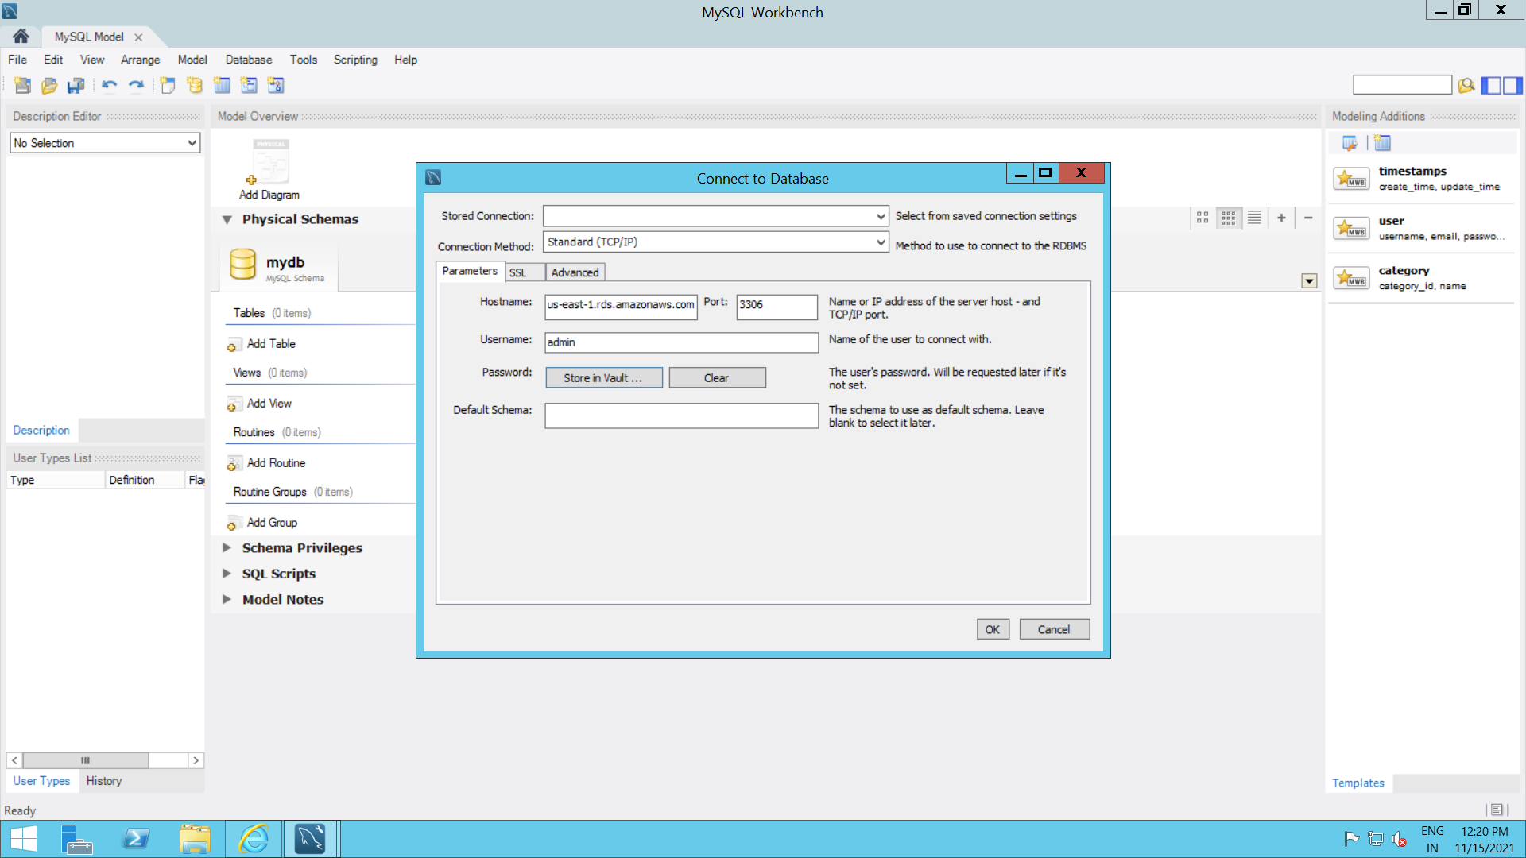

Output: Finally, connect to the MySQL engine from Windows Instance

